Project Proposal

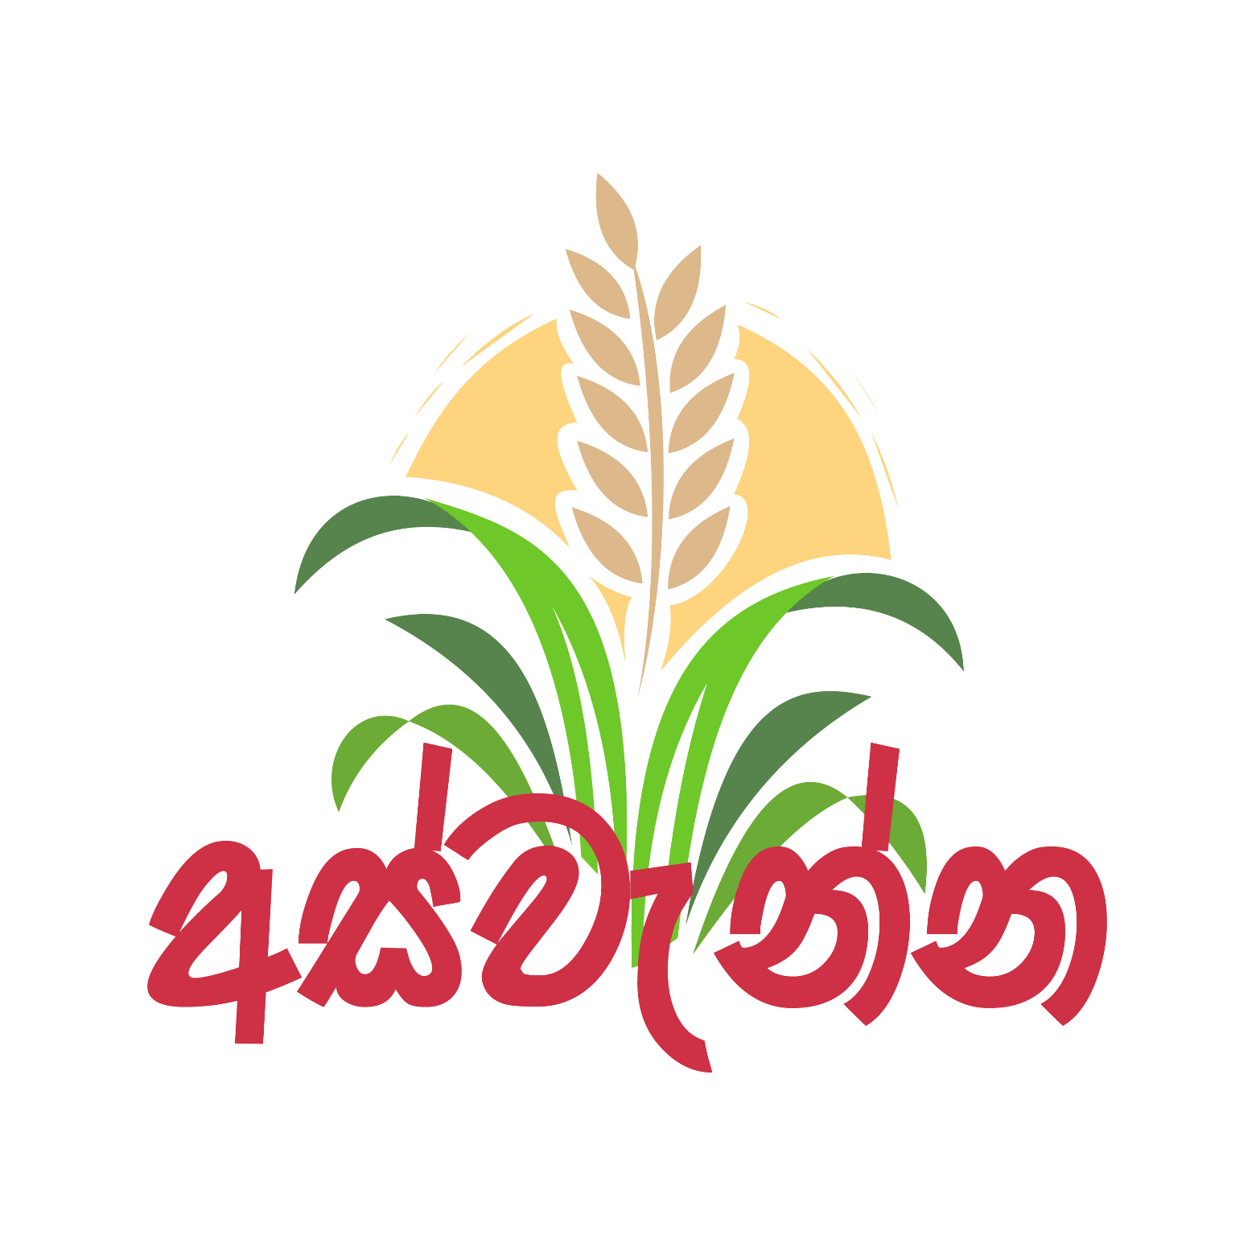

**Name : Y.A.O.D.Yapa**

**Index No : AS2017956**

Table of Contents

01.INTRODUCTION 3

1.1 Background 3

1.2 Problem Statement 3

1.3 Main Objective 3

2.0 METHODOLOGY 3

3.0 SOFTWARE & IMPLEMENTATION 4

4.0 PROJECT TIMELINE 5

5.0 REFERENCE 5

# 01.INTRODUCTION

## 1.1 Background

This application is basically about managing productions of farmers in Sri Lanka. Basically It clearly make direct interconnection among farmers and buyers. It may avoid the wastage because of being unable to find market and reduce the cost for brokers. By using these App farmers can list their products with their market price. Then in other side buyers can view what they need and contact farmers directly without brokers. I hope to give more advice for farmers to minimize wastage of their products.

## 1.2 Problem Statement

Sri Lanka is an agriculture country. most of the people in Sri Lanka live by farming. Many farmers are helpless with no way to sell their produce. In addition, farmers are less knowledgeable about storing and handling their produce without wastage. Therefore, I propose the development of this produce managing application whereby the farmers can have access to sell their produce and get more profit without hiring brokers. Also they can get information about managing and handling produce to get valuable their profession.

## **1.3 Main Objective**

To develop an Android Based produce managing and guide application that will provide marketplace to farmers in Sri Lanka. And also I hope to generate new trend among farmers in Sri Lanka.

# 2.0 METHODOLOGY

* First of all, users (Farmers & Buyers) can register with my app and then they can log in the app.
* I hope to design app home page separately for farmers and buyers. When farmers log in to the app they can view their listed products and buyer notifications. When buyers log in to the app they can choose what are they want.
* Then farmers can add their products and buyers can contact those farmers using the app.
* And also I hope to suggest most visiting products when buyer search.
* I hope to create profiles for all users in this app.
* I hope to provide a chat section to communicate farmers and buyers.
* When a buyer wanted to know farmer’s location then I hope to pass google map coordinates to buyer with farmer’s permission.

# 3.0 SOFTWARE & IMPLEMENTATION

* I hope to use flutter framework and firebase database system to develop my App.

**Flutter (software)**

Flutter is an open-source UI software development kit created by Google. It is used to develop applications for Android, iOS, Linux, Mac, Windows, Google and the web from a single codebase. The first version of Flutter was known as codename "Sky" and ran on the Android operating system. It was unveiled at the 2015 Dart developer, with the stated intent of being able to render consistently at 120 frames per second. During the keynote of Google Developer Days in Shanghai, Google announced Flutter Release Preview 2 which is the last big release before Flutter 1.0.

On December 4 in 2018, Flutter 1.0 was released at the Flutter Live event, denoting the first "stable" version of the Framework. On December 11 in 2019, Flutter 1.12 was released at the Flutter Interactive event. On May 6 in 2020, the Dart SDK in version 2.8 and the Flutter in version 1.17.0 were released, where support was added to the Metal API, improving performance on iOS devices (approximately 50%), new Material widgets, and new network tracking tools.

**Firebase Real-time Database**

The Firebase Real-time Database lets you build rich, collaborative applications by allowing secure access to the database directly from client-side code. Data is persisted locally, and even while offline, real-time events continue to fire, giving the end user a responsive experience. When the device regains connection, the Real-time Database synchronizes the local data changes with the remote updates that occurred while the client was offline, merging any conflicts automatically.

The Real-time Database provides a flexible, expression-based rules language, called Firebase Real-time Database Security Rules, to define how your data should be structured and when data can be read from or written to. When integrated with Firebase Authentication, developers can define who has access to what data, and how they can access it.

The Real-time Database is a NoSQL database and as such has different optimizations and functionality compared to a relational database. The Real-time Database API is designed to only allow operations that can be executed quickly. This enables you to build a great real-time experience that can serve millions of users without compromising on responsiveness. Because of this, it is important to think about how users need to access your data and then structure it accordingly.

# 4.0 PROJECT TIMELINE

|  |  |  |  |  |  |  |  |  |  |  |  |  |
| --- | --- | --- | --- | --- | --- | --- | --- | --- | --- | --- | --- | --- |
| **Activity** | **September** | | | | **October** | | | | **November** | | | |
| UX Design |  |  |  |  |  |  |  |  |  |  |  |  |
| UI Design |  |  |  |  |  |  |  |  |  |  |  |  |
| Interface Design |  |  |  |  |  |  |  |  |  |  |  |  |
| Collecting Details |  |  |  |  |  |  |  |  |  |  |  |  |
| Coding |  |  |  |  |  |  |  |  |  |  |  |  |
| Testing |  |  |  |  |  |  |  |  |  |  |  |  |
|  | **W1** | **W2** | **W3** | **W4** | **W1** | **W2** | **W3** | **W4** | **W1** | **W2** | **W3** | **W4** |

# 5.0 REFERENCE

Introduction of flutter platform:

<https://flutter.dev/docs>

Development tutorials:

<https://www.youtube.com/>

Other Information:

<https://www.doa.gov.lk/>

Name : Y.A.O.D.Yapa

Index No : AS2017956